JOB DESCRIPTION 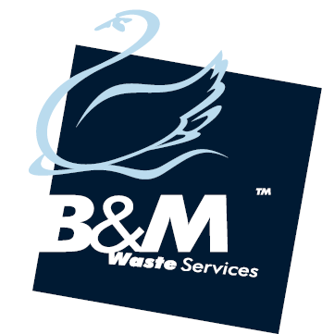

**JOB TITLE**…………………… General Operative with FLT / Telehandler Licence

**DEPARTMENT**……………. MRF

**LOCATION**…………………. Bromborough

**REPORTING TO**…………. MRF supervisor

**JOB PURPOSE:**

To sort segregate and remove contaminates from various waste streams for re-cycling, operate static/mobile plant and generally assist in the operations of the site using best possible practices.

**TASKS**

* Conduct daily pre-user checks and report any defects
* Move bales from bale wrapper to storage area
* Loading/unloading vehicles safely and efficiently
* Maintain a clean, neat and orderly work area internal and external assist in maintaining the security of the facility
* Clean and maintain plant and equipment
* Operate static plant (bale wrapper/compactors)
* Sort single stream materials
* Bale Single stream materials
* Sorting single stream materials across a picking line (Bromborough)
* Sorting single stream materials next to walking floor
* Identify and communicate to management contaminated loads
* Manually load cardboard in to pit
* Maintain a good quality of material produced on site

**OTHER DUTIES INCLUDE BUT ARE NOT LIMITED TO:**

* Carry out safety checks (Safetech, Emergency Stops)
* Work in accordance with safe systems of work and risk assessments
* Take responsibility for housekeeping specific areas of the yard and transfer station
* To be familiar with all policies and procedures relating to waste handling
* To assist management to control and co-ordinate a safe and efficient site
* Ensuring building secured when leaving site
* Attend all training sessions including toolbox talks
* Assisting in other departments when required
* Undertake any additional duties commensurate with the post.

**REQUIRED:**

* The FLT operator must have satisfactorily completed a skid steer training programme and hold the necessary licence.
* The ability to work on own initiative and as part of a team.
* Flexible working attitude.
* Familiarity with material handling

**DESIRED:**

* The use of radio frequency equipment
* Manual Handling training certificate